**National University of Computer & Emerging Sciences, Karachi**

**Computer Science Department**

**Spring 2023, Lab Manual – 05**

|  |  |
| --- | --- |
| **Course Code: CL-217** | **Course: Object Oriented Programming Lab** |
| **Instructor(s) :** | **Abeer Gauher, Hajra Ahmed, Shafique Rehman** |

**LAB - 5**

# Arrays, Array list and Static Keyword

**Arrays:**

Java array is a construct which contains elements of a similar data type. Additionally, the elements of an array are stored in a contiguous memory location. It is a data structure where we store similar elements. We can store only a fixed set of elements in a Java array. Array in Java is index-based, the first element of the array is stored at the 0th index, 2nd element is stored on 1st index and so on.

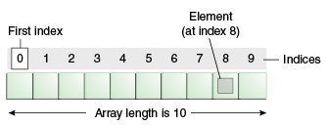

**Types of Arrays**

1. Single Dimensional Array
2. Multi-dimensional Array

**Single Dimensional Array**

**Syntax for Declaration**

## Option 1: dataType[] arr; Option 2: dataType []arr; Option 3: dataType arr[];

**Syntax for Instantiation**

arr = **new** datatype[size];

**Example**

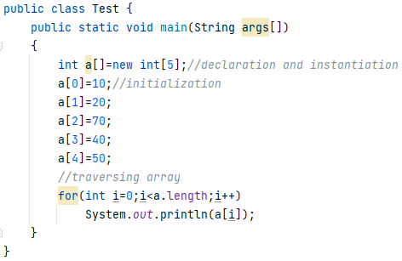

**Multi-Dimensional Array**

In such case, data is stored in row and column based index (also known as matrix form).

**Syntax for Declaration**

dataType[][] arrayRefVar; (or)  
dataType [][]arrayRefVar; (or)  
dataType arrayRefVar[][]; (or)  
dataType []arrayRefVar[];

**Syntax for Instantiation**

int[][] arr=new int[3][3]; //3 row and 3 column

**Example**

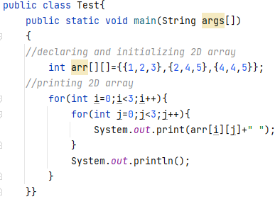

**Passing Arrays to Functions:**

We can pass the java array to method so that we can reuse the same logic on any array.

**Example**

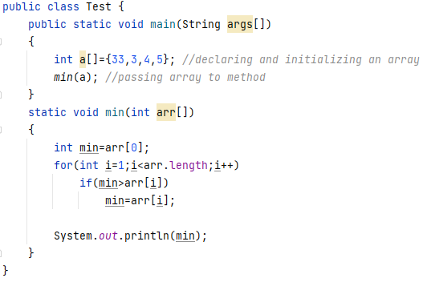

**Java ArrayList**

**ArrayList** class uses a *dynamic*[array](https://www.javatpoint.com/array-in-java) for storing the elements. It is like an array, but there is *no size limit*. We can add or remove elements anytime. So, it is much more flexible than the traditional array. It is found in the *java.util* package.

* ArrayList class can contain duplicate elements.
* ArrayList class maintains insertion order.
* ArrayList allows random access because array works at the index basis.

**Commonly used Constructors**

* ArrayList( ): It is used to build an empty array list.
* ArrayList (int capacity): It is used to build an array list that has the specified initial capacity.

**Common Methods of ArrayList**

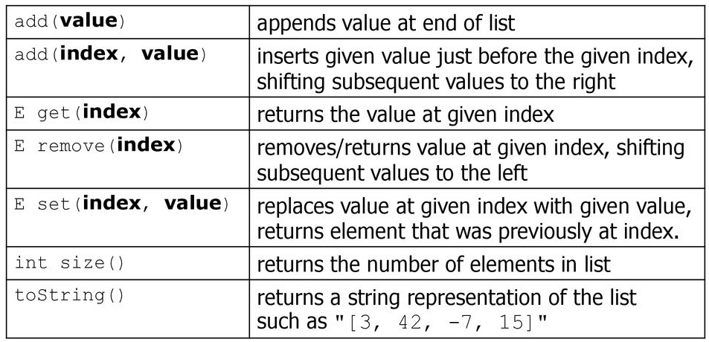

**Additional Methods of ArrayList**

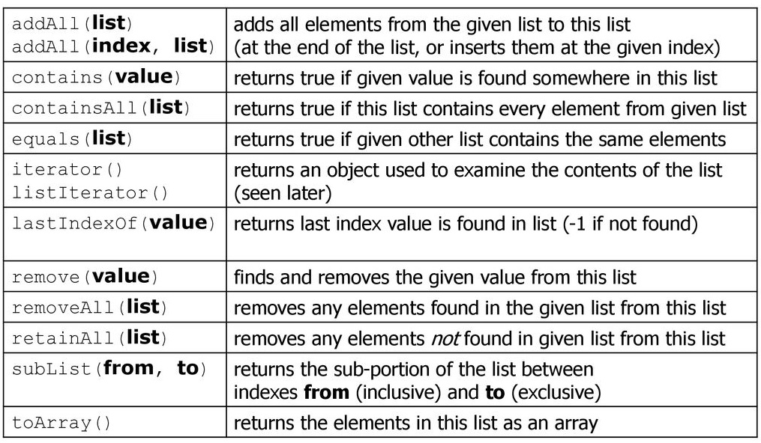

* *You have to import java.util.* to use ArrayList*
* *E refers to type of elements in the above methods*

**Example**

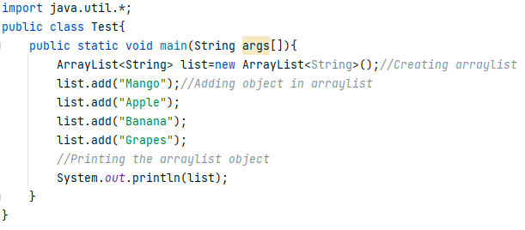

**Iterating ArrayList using Iterator**

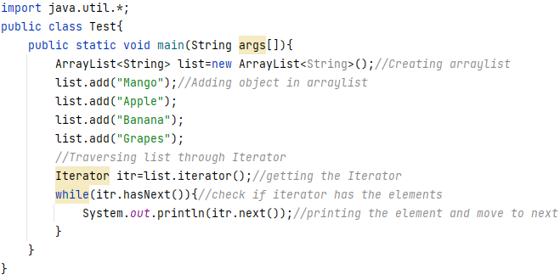

**Example: Sorting ArrayList**

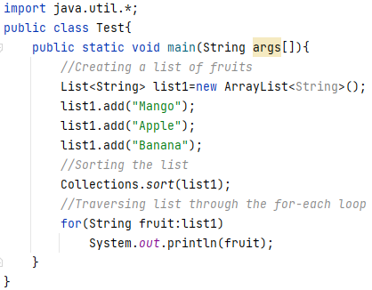

**Static Keyword**

We can apply static keyword with variables, methods, blocks and nested classes. The static keyword belongs to the class rather than an instance of the class.

**Static Variable**

The static variable can be used to refer to the common property of all objects (which is not unique for each object), for example, the company name of employees, college name of students, etc. The static variable gets memory only once in the class area at the time of class loading.

**Example**

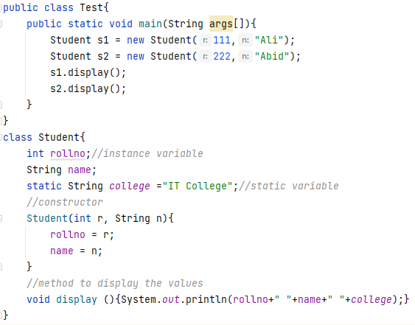

**Static Methods**

A static method belongs to the class rather than the object of a class. A static method can be invoked without the need for creating an instance of a class. It can access static data member and can change the value of it.

**Example**

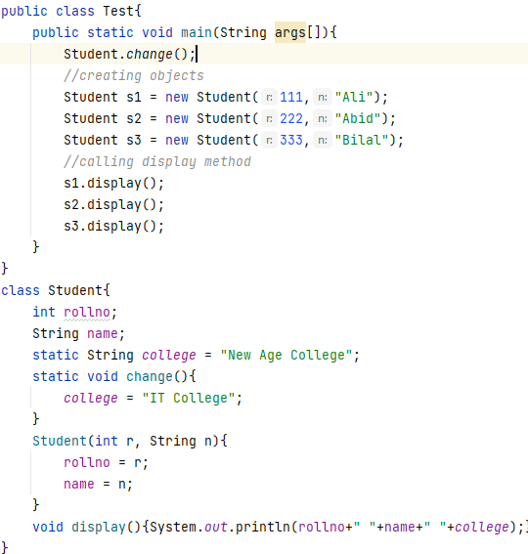

**Task 1:**

Create a class named Average Purchase that will contains an array of size n, if the user has made 3 orders today then then array size will be 3 for today.

* Write a function to take input of the today’s purchases.
* Write a function to display the purchased items.

**Task 2:**

* Create an Array that stores the marks for 5 subjects that you have scored in MID 1.
* Consider that each of them is out of 50.
* Calculate the Maximum marks obtained by You.
* Calculate the Minimum marks obtained by You.
* Calculate the Average marks obtained by You.

**Task 3:**

Create an Array List of String data type. The list will store different programming languages.

* Add five programming languages using the add method.
* Display the array list.
* Change the array list element at the second index.

**Task 4:**

Create an Array list that:

* Ask the user to enter 5 numbers as input
* Check if the list contains a prime number, then display that the list has prime numbers and display the sum of the numbers present at even indices like elements present at 0th, 2nd and 4th indices will be added.
* If the list doesn’t contain prime numbers, then display the sum of the numbers present at odd indices like elements present at 1st and 3rd indices will be added.

**Task 5:**

Create a class called Student that has attributes name, roll number and a static attribute university name.

* Make a static variable counter and initialize it to 0.
* Make a static set method for roll number that increments the counter and returns the counter.
* Create a parameterized constructor that sets the name as the parameter. To set the roll number call the static set roll number method.
* Create a static method that takes a parameter and sets the university name.
* Create a display method that displays the student’s information name, roll number and university.
* In the main, call the set university name method and set it to “FAST University”.
* Create three objects of the student class and display their information along with their roll number that should be different for each student.